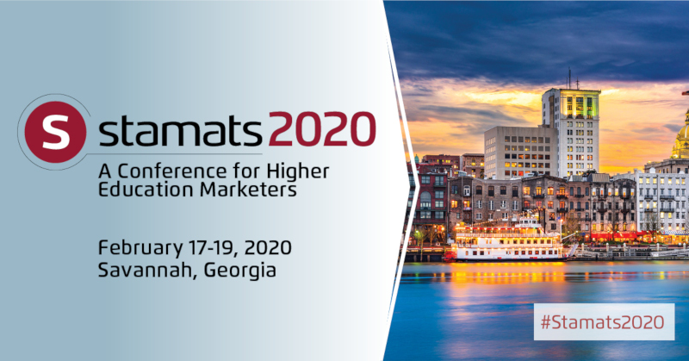
Dear [insert name],
I’d like to attend Stamats 2020: A Conference for Higher Ed Marketers, which will be held February 17-19, 2020 in Savannah, Georgia.
The conference will explore best practices for recruiting traditional students, new strategies for engaging non-traditional students, and the latest tools and research for building relationships with each of these audiences. Every session and workshop will be led by higher education professionals—proven innovators who are helping colleges and universities across the country adapt to shifting demographics and a rapidly changing marketplace.
Stamats 2020 isn’t simply a chance to find out what’s new in field of higher education recruitment, it’s a opportunity to collaborate with other recruitment and marketing professionals, share knowledge, and learn practical strategies to apply resources more effectively.
I realize this is an investment in professional development. My goal will be to learn everything I can, amplify it by sharing it with our internal teams, and then apply it to the success of [insert institution name].
Though the conference offers dozens of sessions and workshops to choose from, I believe the following topics offer the most benefit to our marketing and recruitment goals:
- [insert selection 1]
- [selection 2]
- [selection 3]
- [selection 4]
With your permission, I’d like to take advantage of the early bird pricing by registering for Stamats 2020 before December 31, 2019. You can learn more about the conference and explore the full list of session topics by visiting go.stamats.com/higheredconf.
Thank you for considering my request. I look forward to attending and representing [insert institution name]. Please let me know if there’s any additional information I can provide.

Sincerely,
[insert your name]

